Lathe’s Progress Report #3

* Student: Tran Hoai Uc

ID: M215104

* Student: Rosani Mujica

ID: M228544

DATE: 29/08/2017

# Motor’s base support

**Designing base support for the motor on the X-axis**

I and Rosani Mujica have finished the Motor’s base support. The amount of time to make the base support took longer than expected due to the inaccurate in measurements and designs on the Cross-slide and Saddles from previous semester. As a regard, we have to do re-measuring and re-design those two parts. From then, we can accurately place the base support with the Spacer and Ball screw bearing that Ross had made.

The design is tedious and take an amount of time due to ours inexperience. However, with the purpose to make it easier for Tom to produce the part which is also has a strong base to hold the motor without any bending.

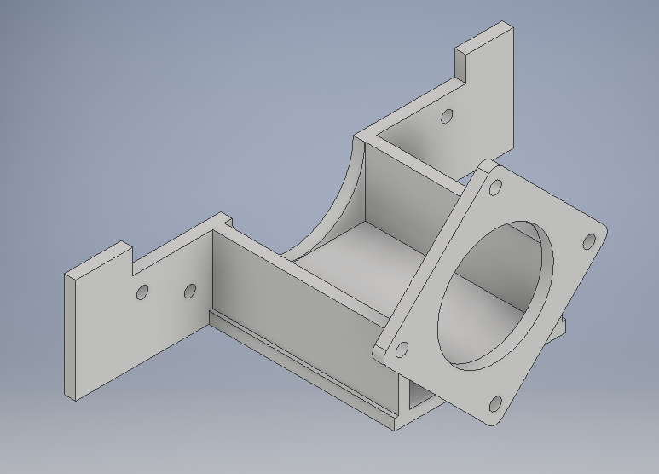

**Finished motor’s base support**

The following are the dimension of the base support:

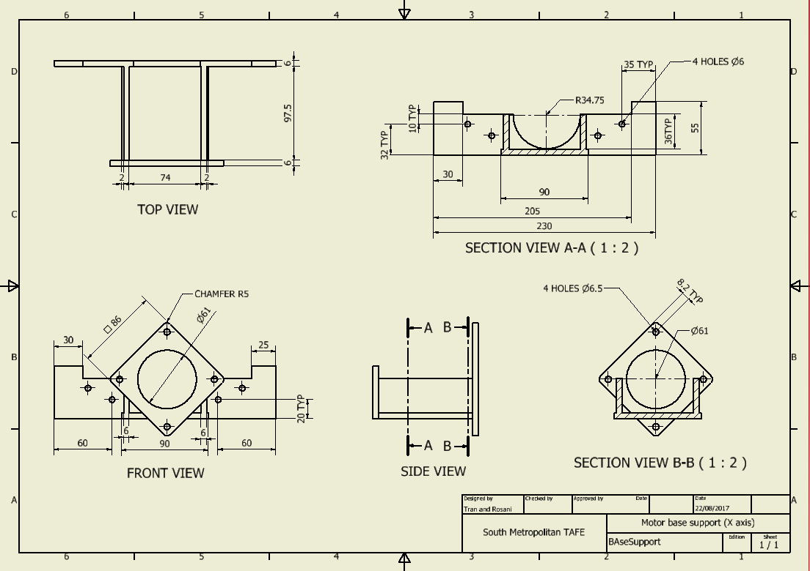

# Shaft end’s base support

Failures or in accuracy while machining could be a major problem without the unstable shaft. For that reason, we are on progress to produce the shaft’s end base support. However, we are currently struggling on the design because of unknown difficulty to put the ball screw bearing onto the shaft.